TOAST MAGAZINE
20th January 2021

Material Issues

ARTS & CULTURE
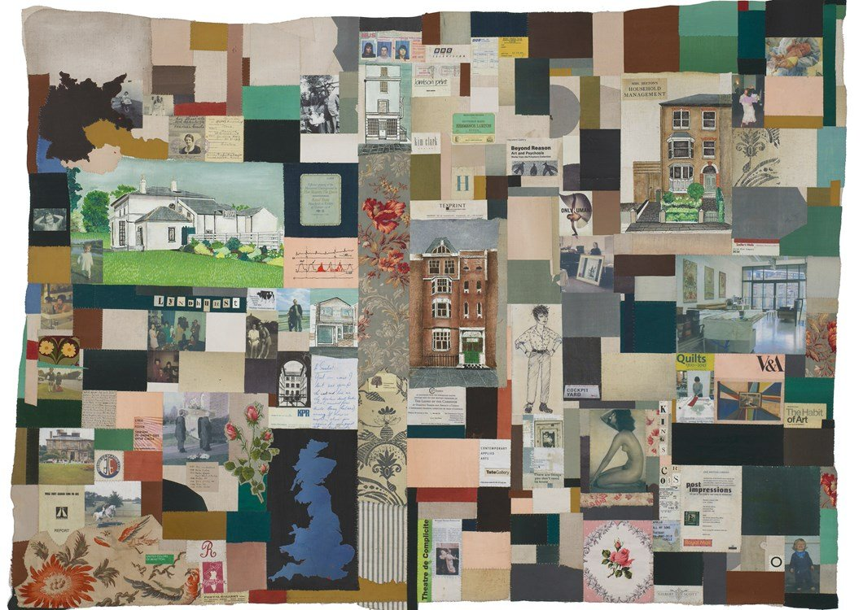
Art is frequently about the interrogation of self, the who? The why? The what might be or what might have been? For artist Natasha Kerr, it is a central driver of her work. Kerr who works with antique textile and photography, initially examined her own family background, however over the course of her career, she has investigated not only the lives and stories of clients, but also of fictional personalities of her own creation. “Telling a story is fundamental to my work,” she says, “but first I do a great deal of research.”
Kerr’s grandfather Otto came to Britain to escape the Nazis in 1936. A successful surgeon and specialist in women’s health, who trained under Freud, he was the son of a highly renowned Viennese tailor. As for so many political immigrants and asylum seekers today, his life’s trajectory and that of his family changed dramatically. This became a crucial focus for his Granddaughter, Natasha Kerr. At the centre of her ‘At the End of the Day,’ (used by the V&A as the lead image for their Quilt exhibition in 2010,) is a photo of her grandfather Otto, lying on a sheet in the garden, in front of an empty chair alongside his mother, whose face is covered by a handkerchief, all set in a multicoloured adapted Union Jack flag. It is according to Kerr a “displacement flag” an image perhaps of those left behind, those who are missing or about just not belonging anywhere.
This sense of dislocation or searching for the story of what makes sense of individual lives is the theme of much of her work, all of which is deeply considered, explored and researched. Her own family research culminated some 20 years ago, in ‘There Are Things You Don’t Need to Know,’ an extraordinary, haunting installation comprising a series of textile artworks and medical paraphernalia, enhanced by smell and sound, set in a decaying terrace house in South London. Kerr wanted to show her work not in a fractured way as just a series of anecdotes, but to make it understandable as a chronology of a family. “It is a proper story of migration, change and the cycle of life,” she explains. She wanted her family to be seen in a house, rather than a sterile white gallery, so she self-funded the show and in the process nearly bankrupted herself. Being textile-based, it failed to attract the attention of fine art critics, who only later came to re-evaluate the use of textile as a valid artistic medium.
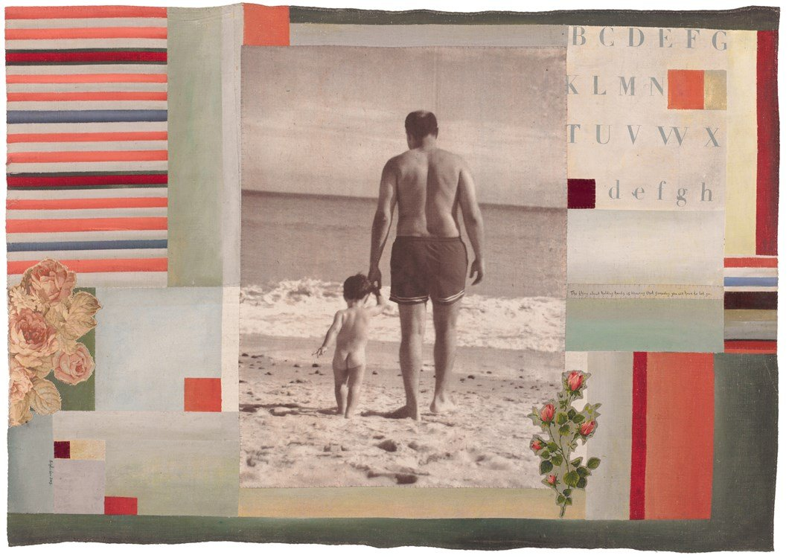
For Kerr, stitch is a form of family language, derived not only from her grandfather’s surgical skills, but via the matriarchal household of three generations, in which she was raised. Her great grandmother and grandmother made clothes for Harrods, Kerr made her own clothes and developed her own style. During her textile course at Brighton University, she created what she calls “very distressed’ fabrics based on Italian frescoes, which always showed the touch of the human hand. “I love things with soul,” she explains. “It’s a dichotomy because I don’t like broken things, yet I love age and patina. I like the interaction between the human being and the object. There must be care in the construction, which is reflected in the object.”
After graduation Kerr designed printed fashion textiles using Renaissance imagery creating work with a ghostly feel. Her breakthrough into fine art came when her mother gave her a forgotten album of old photographs. Kerr transferred them to vintage textiles, trying to establish the whys and whens of the family members in the images. Each textile panel was hand painted, hand sewn, silk screen-printed, transfer-printed and pieced together. “Hand stitching is important,” says Kerr. “ It is very different to using a machine … it looks different, it is less regimented, less immediate and stitching by hand takes time.” Finally Kerr augments the story by writing on the work using a fine paint brush and Indian ink.
Kerr’s family pieces led to a series of exhibitions, including a solo show at the Ruthin Gallery. Subsequently Kerr created artworks for hotels and restaurants alongside designing book jackets for Penguin Random House and Hodder. In 1999 she was commissioned to create a Royal Mail Millennium stamp design depicting the suffrage movement.
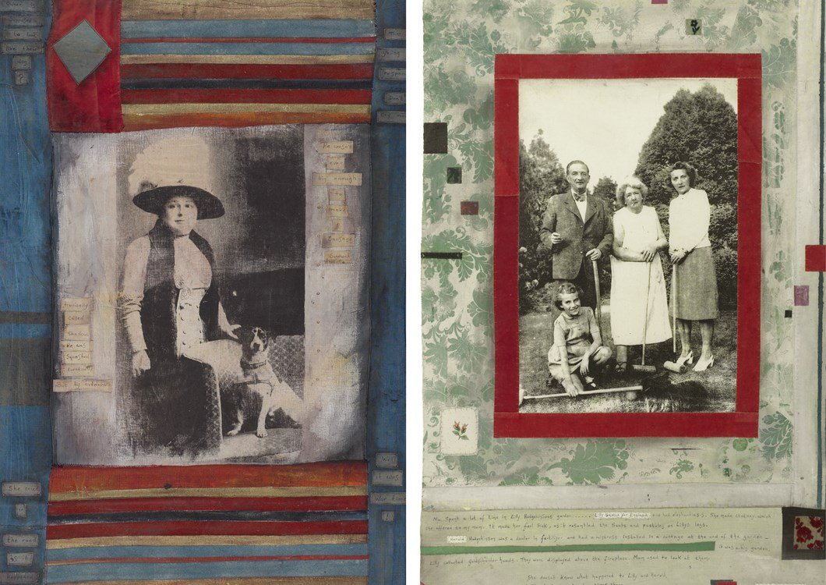
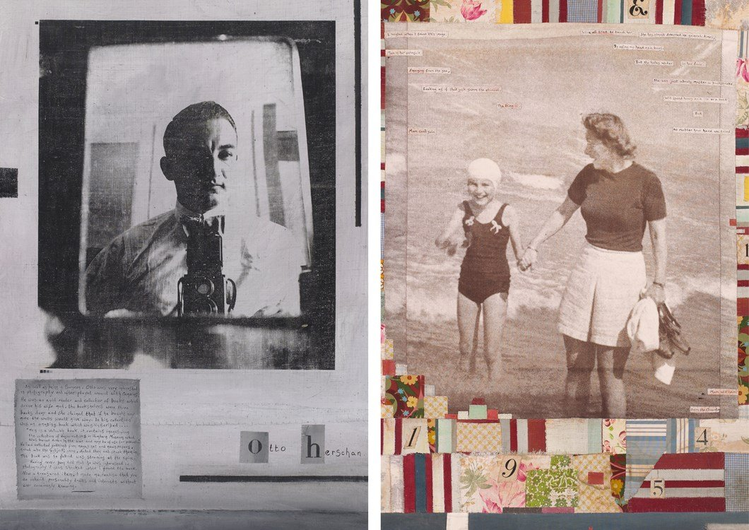
Kerr is regularly commissioned to do textile portraits of others, (often as a surprise gift.) Her approach is forensic, mixed with the psychological. Each subject is researched in conversation with family members and friends. “I am creating heirlooms,” she says, “but ones that the public will never see. I am creating not a decorative object but something that reflects who the recipient is, how others perceive them or how they perceive themselves. These are stories that would otherwise get lost,” she explains. “In a throwaway society it is giving something with love and personal involvement. It is a dialogue and negotiation; a kind of therapy perhaps and it can be very intense. Everything I do starts with the story.”
In her self-generated pieces, Kerr is equally driven. She constructs whole fictitious histories, based on found images. “They inspire the type of character I will create, what did he do for a living, when was he born, where was he born and it goes from there. I will research what happened at the time the person lived, what were the innovations, what was the zeitgeist. I then try to convey elements of the story within the piece. The actual story is also written onto the piece. All of the characters could have inhabited the background that they find themselves in.”
All Kerr’s fictional characters are based on facets of human nature; on the trigger points that change people. Indeed all Kerr’s work involves an analysis of human behaviour, but also the stories of people’s lives, both those that they create and the factual ones. To date, most of Kerr’s work has been about other people, only one work has been a self-examination. She is both an author and a fine artist. Her artistic ability relies not just on the creation of a striking and beautiful image, but on her understanding of what it is to be human.

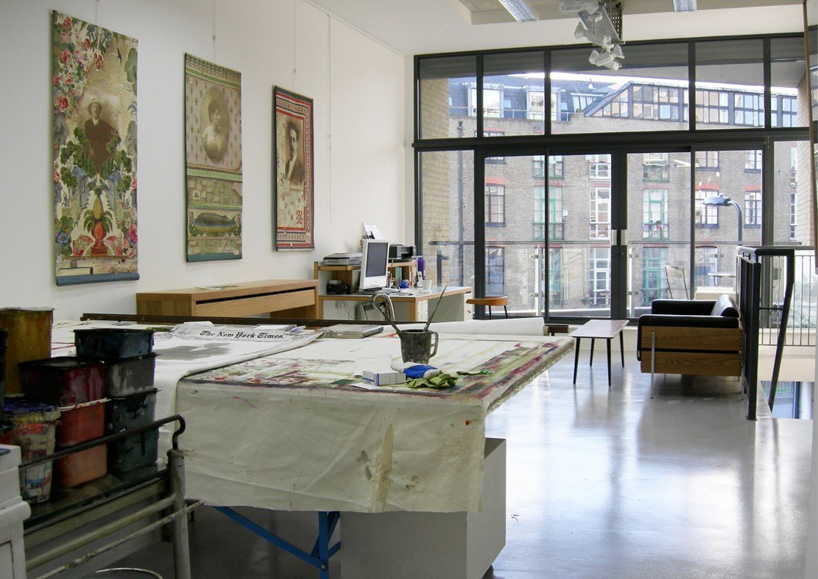
“I think what I try to do is make incredibly personal work for people. It’s very intimate and if people have the capacity to let me, I’m very happy to go on that journey with them. A bond is formed, but unlike with a therapist, as an artist you can carry on that relationship.” That therapy analogy is apt. After the birth of her son, Kerr wanted to learn something new and to stretch herself. To add depth to her practice, Kerr is training to be a psychoanalytic therapist. “It’s more about how you feel about your narrative. I’m listening in a different way. I listen to understand, rather than the actual words. This has given me more confidence and allowed me to gradually let go of formulas and just flow.”
Interview by Corinne Julius.
Images courtesy of Natasha Kerr. 'Otto the Photographer’, 1998, 156cm x 87cm, 'Tante Gertude Gast', 1995, 144cm x 98cm, 'Holding Hands', 2006. 160cm x 110cm, 'Fag Ash Lill', 1997, 150cm x 94cm, 'But Mum Can’t Swim', 2002, 196cm x 142cm. Copyright for all images, Natasha Kerr.

COMMENT HERE
Emily
2 days ago
I'm in love with your work. I found you through researching quilting and textiles for a uni project. The way you have incorporated your family history into your art is beautiful. This is going to be a big inspiration for the work I create going forwards!
REPLY
Natasha
a day ago
Thank you Emily.
New website coming soon
Amanda
19 days ago
These are just beautiful and seem such an act of love. I feel inspired to have a go myself. Thank you Natasha
REPLY
Natasha
19 days ago
Hi Amanda,
They are an act of love and of exploration. When we can see people face to face again, I hold workshops in my studio to
Inspire people to start the journey, and to have a go.
Su
20 days ago
I loved this article. I have seen Natasha’s work before in Liberties and was enormously impressed with the detail that went into the individual pieces.
I certainly hope to see more of Natasha’s beautiful work soon.
REPLY
natasha
20 days ago
Thanks Su,
I really enjoyed showing my work in Liberty, I'm pleased that you saw it there, it is such a special iconic London treasure trove.
Karlyn
22 days ago
This is a beautiful piece, and it's so lovely to learn about Natasha's background and process - in particular, the idea of making as a form of family language is one that is of great interest and resonance.
I would have loved to have seen 'There Are Things You Don’t Need to Know' - are there any images/documentation online?
REPLY
Natasha
22 days ago
Hi Karlyn,
Unfortunately my website has gone whoosh, as it was on adobe flash, which has become obsolete. I had not realised. I will be redesigning it. When it is up again, the images will be on there. www.natashakerr.co.uk
Juliet
23 days ago
I commissioned a “portrait“ which was great fun and a great success. It was good to be reminded of her other projects. I was dubious about her following the course as I thought she would not have time for her art but I am now totally reconciled!
REPLY
Natasha
20 days ago
Thank you Juliet. I've always enjoyed working to commission, and your was a special one.
Kevin
24 days ago
Wow
I love all this.
My wife has just investigated her family tree and I am thinking that this could be incorporated in some very special and personalised artwork.
Looks great!
Need your email Natasha
REPLY
natasha
22 days ago
Hi Kevin.
I will ask Toast to forward my details.
Best wishes
Natasha
Sophie
24 days ago
I am overwhelmed by the resonance I feel with this beautiful article and now I so wish to meet Natasha. As a cellist and creator in sound, word and textile and as a person for whom story telling and working with our hands seem to be fundamental to our human connectivity I have never felt more strongly the need to reach out to the call of this sort of wisdom. If there is any possibility of putting me in touch with Natasha I would be so happy.
REPLY
natasha
24 days ago
Dear Sophie,
Thank you for your lovely comments.
I would be happy for you to contact me.
Maybe Toast can forward my e.mail?
Best wishes Natasha
Valerie
25 days ago
I love this work - really beautiful colours. An interesting and distinctive approach to portraiture.
REPLY
natasha
22 days ago
Thank you Valerie.
Natasha
20 days ago
Thank you Valerie. I enjoy working with colour.
monica
25 days ago
What an insightful article. Stitch as language indeed. Then what a gifted linguist Natasha is!
A friend took me to the installation mentioned here "There are things you don't need to know" and it still remains one of the most interesting, thought-provoking art experiences I've ever seen.
REPLY
Natasha
24 days ago
Thank you Monica.
Oona
a month ago
What a Beautiful and intimate article, weaving together the personal and the historical, fact & fiction in a wonderful observation of human-ness
REPLY
Sean
a month ago
What a fascinating insight into Natasha's work. In a world where photos are trapped on sim cards or in the icloud, it's heartening to see a fine artist giving family snaps a certain dignity and longevity by transforming them into lasting works of art. Because they are so personal it would be amazing to see a collection of Natasha's work exhibited. Are there any plans to exhibit her work in the future?
REPLY
Catherine
a month ago
What a wonderful article so beautifully written . I know Natasha well and there were new things in this piece that I discovered about her which was a real joy .Sensitve work so personal and with so much attention to detail.
REPLY
natasha
a month ago
Thank you.
Tim
a month ago
Natasha: It's good to read about your family background, and in such a fine article. I was especially impressed by the final three sentences! Tim
REPLY
Kathleen
a month ago
Hi Natasha
I love your work .I am a child of migrants and a print maker ,so its very inspiring me to see this work .
really like it
Kathy
REPLY
natasha
a month ago
Thank you Kathy.

Keep up to date with our latest articles and news
SIGN UP

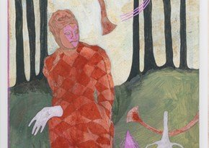

In the Studio with Painter Ella Walker

Painting, drawing and fresco form the basis of Ella Walker’s artistic practice.
4 months ago

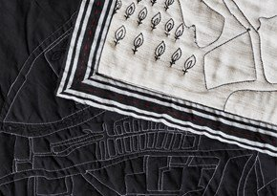

Artist in Residence | Kate Owens

We talk to Artist-in-Residence Kate Owens about her innovative block print technique.
4 months ago

TOAST Podcast | Series 4 | Flux & Flow

Our fourth series looks at how we navigate change and the forces that steer our lives.
4 months ago

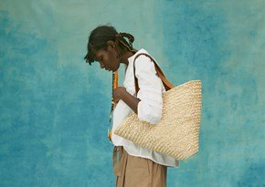

Delali Ayivi and Bubby Nurse | Emerging Artists

Emerging artists Delali Ayivi and Bubby Nurse create the TOAST Spring Summer ’21 Lookbook.
15 days ago

The Art of the Bath | A Meditative Escape

Why the meditative act of bathing has captured artists' imaginations for hundreds of years.
19 days ago

Easy Mends by Emily Settle | Time to Make

A simple guide to two textile mends by repair specialist Emily Settle.
22 days ago

Women’s Work | Celebrating Female Creativity

The life and work of six female artists left out of the traditional story of art.
25 days ago

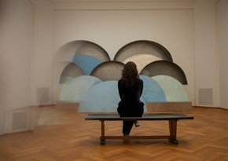

A Curator's View | Kunstmuseum Den Haag

Yasmijn Jarram explores the relevance of contemporary art and its relation to society.
2 months ago

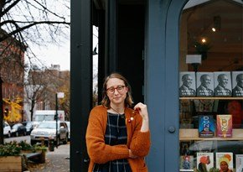

Emma Straub of Books are Magic | TOAST Insider

The American novelist and bookstore owner on running an independent business with community at its heart.
2 months ago

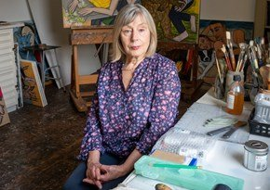

In the Studio with Eileen Cooper

Chloë Ashby talks to the celebrated British artist, known for her figurative paintings of monumental, mythic women.
2 months ago

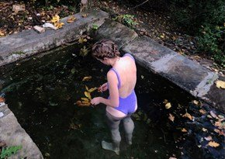

Painting the Weightless and Undiluted Vitality of Open Water

Emily Ponsonby captures female forms submerged in the greenish-blue depths of water.
3 months ago

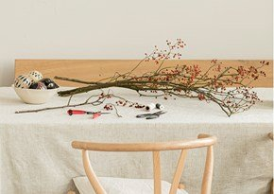

Marieke Verdenius of The Gatherists | Meet the Founder

Marieke on her journey, the meaning of gathering and tips for dressing a winter table.
3 months ago

Alphabet Wrapping Paper with Rachel Hazell | Time to Make

A guide by Rachel Hazell for making bespoke wrapping paper.
3 months ago

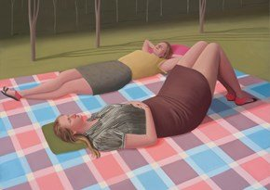

In the Studio with Prudence Flint

Chloë Ashby talks to the Australian artist about her work painting strong female characters.
4 months ago

Objects of Meaning | Ekta Kaul

The textile works of Ekta Kaul are intricately embroidered objects of place and belonging.
4 months ago

In the Studio with Painter Ella Walker

Painting, drawing and fresco form the basis of Ella Walker’s artistic practice.
4 months ago

Artist in Residence | Kate Owens

We talk to Artist-in-Residence Kate Owens about her innovative block print technique.
4 months ago

TOAST Podcast | Series 4 | Flux & Flow

Our fourth series looks at how we navigate change and the forces that steer our lives.
4 months ago

Delali Ayivi and Bubby Nurse | Emerging Artists

Emerging artists Delali Ayivi and Bubby Nurse create the TOAST Spring Summer ’21 Lookbook.
15 days ago

The Art of the Bath | A Meditative Escape

Why the meditative act of bathing has captured artists' imaginations for hundreds of years.
19 days ago

Easy Mends by Emily Settle | Time to Make

A simple guide to two textile mends by repair specialist Emily Settle.
22 days ago

Women’s Work | Celebrating Female Creativity

The life and work of six female artists left out of the traditional story of art.
25 days ago

A Curator's View | Kunstmuseum Den Haag

Yasmijn Jarram explores the relevance of contemporary art and its relation to society.
2 months ago

Emma Straub of Books are Magic | TOAST Insider

The American novelist and bookstore owner on running an independent business with community at its heart.
2 months ago

In the Studio with Eileen Cooper

Chloë Ashby talks to the celebrated British artist, known for her figurative paintings of monumental, mythic women.
2 months ago

Painting the Weightless and Undiluted Vitality of Open Water

Emily Ponsonby captures female forms submerged in the greenish-blue depths of water.
3 months ago

Marieke Verdenius of The Gatherists | Meet the Founder

Marieke on her journey, the meaning of gathering and tips for dressing a winter table.
3 months ago

Alphabet Wrapping Paper with Rachel Hazell | Time to Make

A guide by Rachel Hazell for making bespoke wrapping paper.
3 months ago

In the Studio with Prudence Flint

Chloë Ashby talks to the Australian artist about her work painting strong female characters.
4 months ago

Objects of Meaning | Ekta Kaul

The textile works of Ekta Kaul are intricately embroidered objects of place and belonging.
4 months ago

In the Studio with Painter Ella Walker

Painting, drawing and fresco form the basis of Ella Walker’s artistic practice.
4 months ago

Artist in Residence | Kate Owens

We talk to Artist-in-Residence Kate Owens about her innovative block print technique.
4 months ago

TOAST Podcast | Series 4 | Flux & Flow

Our fourth series looks at how we navigate change and the forces that steer our lives.
4 months ago

SUB-TOTAL: £0.00
VIEW SHOPPING BAGCHECKOUT
- DELIVERY & COLLECTION
- RETURNS
- SIZE & FIT
- SHOP LOCATOR
- SIGN UP
- RECOMMEND A FRIEND
- CARE GUIDE
- CONTACT US
- LOOKBOOK
- ABOUT US
- WORK WITH US
- EVENTS
- ETHICAL POLICY
- PRIVACY & TERMS
- HELP
- SITEMAP

